Prehospital Ocular Irrigation Protocol Addendum
*This addendum adapts the practiced Emergency Room Ocular Irrigation Protocol for use by prehospital EMS and Fire personnel. All content in this section is specific to the field environment and is highlighted to distinguish it from the original Emergency Room protocol in place.

Prehospital Purpose
To provide a standardized, field-ready protocol for ocular irrigation using the Morgan Lens in prehospital EMS and Fire settings, particularly during chemical, HazMat, fireground, industrial, or blast-related incidents. The goals are to: (1) initiate bilateral irrigation as early as possible, (2) prevent avoidable vision loss & injury and (3) reduce downstream ED and nursing workload by delivering patients with irrigation already well underway.

Operational & Clinical Rationale in the Field
Fire and EMS crews frequently encounter airbag deployment, chemical agents, fire suppression products, industrial cleaners, battery chemicals, fuels, combustion byproducts, and airborne debris. These exposures often involve both eyes, even when the patient reports symptoms in only one eye.
Prehospital Morgan Lens use allows responders to begin continuous, hands-free bilateral irrigation during extrication, decontamination, and transport. This protects the ocular surface, removes particulate and chemical agents earlier, and reduces the burden on ED staff by ensuring that large-volume irrigation has already been started before hospital arrival.

Prehospital Indications for Morgan Lens Use
Use the Morgan Lens in the prehospital setting when intensive, continuous eye irrigation is needed, including:
• Chemical burns or caustic splashes (acid or alkali) from industrial, household, or automotive products including air bag deployments. This includes bleach, concrete, lime, ammonia, detergents, battery acid, fuels, and similar agents.
• HazMat incidents involving liquid, powder, aerosol, or gas exposures that could contact the eyes.
• Fireground exposures to smoke, soot, irritant gases, fire suppressants, or debris that cause significant eye pain, tearing, or visual disturbance.
• Non-embedded foreign bodies such as sand, glass fragments, metal shavings, or wood chips when simple eyewash or manual removal is not sufficient.
• Foreign body sensation with no visible object after flushing, when micro-particles are suspected in one or both eyes.
• Blast-related injuries or explosions where both eyes may have been exposed to debris or chemical agents.
• Unless it is absolutely clear that only one eye is affected, prehospital providers should apply bilateral irrigation.

Prehospital Contraindications (Same as ED, Applied in the Field)
The same major contraindications apply in the field as in the Emergency Room:
• Suspected or confirmed globe rupture (obvious deformity, extrusion of intraocular contents, or full-thickness laceration).
• Protruding foreign body from the eye.
• Severe, uncontrolled facial trauma that prevents safe access to the eye.
If one eye has a suspected globe rupture and the other eye has a chemical exposure, irrigate only the exposed eye that is safe to treat and protect the injured globe with a shield without applying pressure.

Prehospital Equipment Kit (Suggested Rig or Engine Setup)
To make field use of the Morgan Lens rapid and consistent, agencies should stock a pre-built eye irrigation kit on each ALS unit and, when possible, on engines or HazMat rigs. A typical kit includes:
• Morgan Lenses (2) – one for each eye, sterile and single-use.
• Morgan Lens Delivery Set with Y-tubing – preferred method to irrigate both eyes from a single IV bag.
• IV fluids – 1–2 liters of Lactated Ringer’s (preferred) or Normal Saline, with additional bags available on the unit.
• Topical anesthetic drops – proparacaine or tetracaine, if within local scope of practice and allowed by protocol but not necessary to use the Morgan Lens.
• Medi-Duct or similar ocular fluid collection systems to control runoff and reduce mess in the patient compartment.
• Tape or securing devices for tubing and collection devices.
• pH test strips (if carried by the service) to check ocular pH at the scene or during transport.
Kits should be checked at the same interval as other ALS equipment to ensure that Morgan Lenses, delivery sets, and fluids are in date and ready for immediate deployment.

On-Scene Prehospital Procedure (Fire + EMS Roles)
1. Scene Safety and PPE:
• Ensure the scene is safe before initiating care. In HazMat or chemical release situations, coordinate with HazMat teams and use appropriate respiratory and skin protection.
• Use eye protection, gloves, and other PPE to avoid secondary exposure to the responding crew.
2. Rapid Assessment and Decontamination:
• Determine the likely agent (if known), time of exposure, and whether both eyes were in the exposure field.
• If gross contamination is present on the face or body, follow decontamination protocols (e.g., water flush, removal of contaminated clothing) before or along with eye irrigation.
3. Immediate Irrigation – “Irrigate First, Ask Questions Later” for Chemical Exposures:
• Do not delay irrigation to obtain a long history or complete physical exam. Start irrigation as soon as possible, especially for strong alkali or unknown chemicals.
• When in doubt, treat both eyes, as many serious exposures are bilateral even when only one eye is painful.
4. Analgesia and Topical Anesthetic (if available, but unessential):
• If topical anesthetic drops are within scope, place 1–2 drops in each affected eye to improve comfort before Morgan Lens insertion.
5. Equipment Setup in the Field:
• Spike the IV fluid bag with the Morgan Lens Delivery Set or administration set. Attach one Morgan Lens to each branch when bilateral irrigation is indicated and prime the Y-tubing of Morgan Lens Delivery Set or administration set until fluid runs from both lenses.
•
• Position the patient to supine or reclined position on the stretcher when possible. Use Morgan Lens Medi-Ducts to control runoff and protect the ambulance interior from liquid mess.

6. Morgan Lens Insertion:
• Starting flow of solution before insertion is required. Ask the patient to look down while gently inserting the lens under the upper eyelid, then have the patient look up as you drop the lens into place over the cornea, allowing it to float on the layer of solution.
• Repeat for the second eye for bilateral irrigation is indicated.
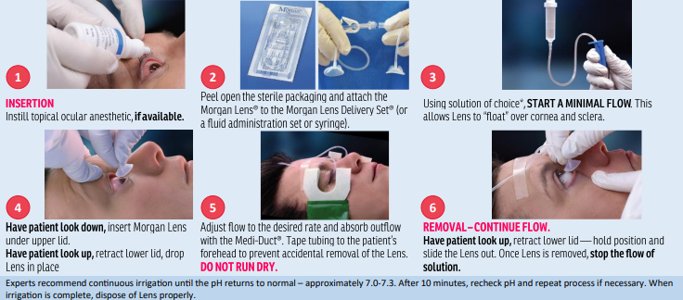
7. Ongoing Irrigation and Monitoring:
• Continue irrigation throughout ??? and transport. Replace fluid bags promptly to avoid interruptions in flow.
• Monitor patient comfort, airway status, and overall condition while the Morgan Lenses free your hands for other care tasks.
• IF pH strips are available, check ocular pH periodically, especially for chemical burns, and continue irrigation until approaching neutral if transport time allows.

Transport and Hospital Handoff
Morgan Lens irrigation can and should continue during transport when indicated. Secure the IV bag, tubing, and Medi-Ducts so that they do not interfere with cot movement, seat belts, or crew access.
During radio or electronic notification to the receiving facility, clearly communicate that Morgan Lenses are in place, whether irrigation is unilateral or bilateral, the fluids used, and approximate volume infused so far.
On arrival, provide a concise handoff that includes the mechanism of exposure, suspected chemical or material, time of injury, prehospital pH readings (if obtained), presence of bilateral Morgan Lenses, total irrigation time, and volume of fluid used. This allows ED staff to continue or modify irrigation without repeating steps already completed in the field.

Prehospital Documentation Recommendations
In the EMS patient care report, document at minimum:
• Description of the exposure (chemical name if known, type of incident, unilateral vs. bilateral exposure).
• Time of exposure and time irrigation was initiated.
• Use of Morgan Lens (unilateral or bilateral), including use of the Delivery Set and Medi-Ducts.
• Type and amount of IV solution used (e.g., total liters of Lactated Ringer’s or Normal Saline).
• Use and name of topical anesthetic and systemic analgesia or sedation, if applicable.
• Any pH readings obtained before or during transport.
• Patient response to irrigation and any complications.
Clear documentation supports continuity of care, quality improvement review, and, when relevant, workers’ compensation or incident investigation needs.

Morgan Lens Instruction for use:

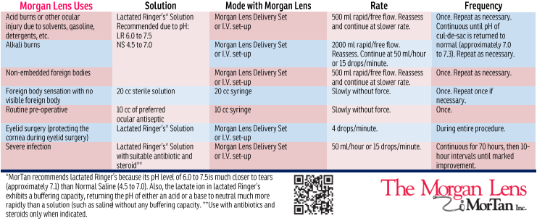Agency Training and Implementation Notes
Agencies adopting prehospital Morgan Lens use should include this addendum in training for EMTs paramedics, and Fire personnel who assist with patient care. Joint training with local Emergency Departments is strongly recommended so that prehospital and in-hospital teams follow a consistent approach to bilateral irrigation. Stocking each ALS unit and key Fire apparatus with two Morgan Lenses, a Delivery Set, Medi-Ducts, and appropriate IV fluids ensures that responders can rapidly initiate bilateral irrigation in the field, aligning prehospital practice with Emergency Room standards and improving patient outcomes.

